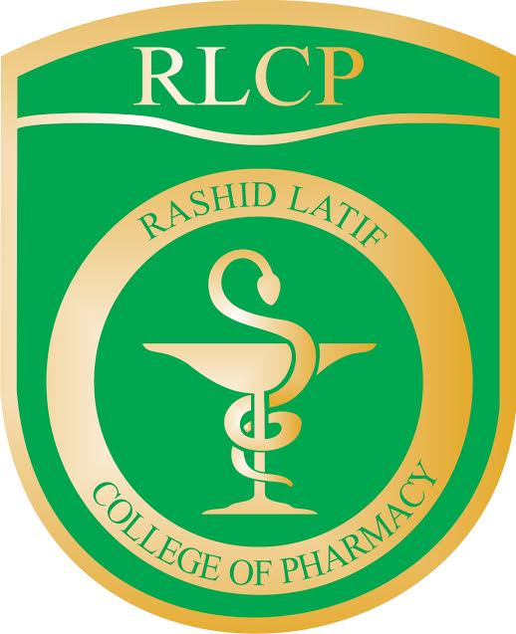

Rashid Latif College of Pharmacy
Rashid Latif Institute of Allied Health Sciences
Library
Membership form for Faculty/Administration/Staff

One Snap
1” X 1”

Name: _________________________ Father’s Name: ________________________

CNIC: __________________________________________________________
(Please tick one)

Department: D-Pharmacy
Name and no. of courses allotted:

DPT (Physiotherapy)
______________________________
Nutrition
_______________________________
MLT(Medical Lab Technology)
_____________________________
MIT (Medical Imaging Technology)

Speech Pathology

Optometry

Other Department ______________________________

Status: Permanent Visiting

Designation: _____________________________________________________

Address: _____________________________________________________

_____________________________________________________

Phone Res: _______________________Cell No: _______________________

E-Mail: _____________________________________________________

________________________
Signature of Library Member ________________
Head of Department

For office use only
Membership ID _________________
Approved/Not approved

_______________________ ___________________
Chairman Library Committee Incharg Library

